[git@github.com](mailto:git@github.com):ppundir/OpenCV-Object-Face-Tracking.git

Raspberry PI

1. Install Raspbian OS.

Need disk utility for windows (Win32 Disk Imager) and Raspbian OS Image.

Burn the Image in SD Card provided.

2. Disk Name(SD Card): Boot  
 Open Boot>>>>Create file named ‘ssh’ without extension inside boot.

## Insert Sd Card in the given slot at the back of Pi.##

##Connect the given power cord with Raspberry Pi##

#Connect raspberry via HDMI to monitor. (only first time)

#default username is pi and password is raspberry.

Download VNC Viewer for Windows from below link( .exe or .msi)

<https://www.realvnc.com/en/connect/download/viewer/windows/>

**On raspberry , install vnc server**

Open command prompt -> sudo apt-get update

-> sudo apt-get install realvnc-vnc-server

sudo raspi-config

Interfacing Options -> VNC -> enable server -> ok -> finish

Open VNC Viewer on windows -> in search box type ip address of raspberry pi.--- ( u will get ip of raspberry by typing ifconfig on terminal inside raspberry view)

----now we are connected to raspberry pi

OpenCV

[https://www.pyimagesearch.com/2017/09/04/raspbian-stretch-install-opencv-3-python-](https://www.pyimagesearch.com/2017/09/04/raspbian-stretch-install-opencv-3-python-on-your-raspberry-pi/)

[on-your-raspberry-pi/](https://www.pyimagesearch.com/2017/09/04/raspbian-stretch-install-opencv-3-python-on-your-raspberry-pi/)

1. Expand filesystem

sudo raspi-config

Advance d options -> Expand filesystem -> Enter -> Finish

If prompted for reboot ok, else sudo reboot

2. Install dependencies

sudo apt-get update && sudo apt-get upgrade

sudo apt-get install build-essential cmake pkg-config

sudo apt-get install libjpeg-dev libtiff5-dev libjasper-dev libpng12-dev

sudo apt-get install libavcodec-dev libavformat-dev libswscale-dev libv4l-dev

sudo apt-get install libxvidcore-dev libx264-dev

sudo apt-get install libgtk2.0-dev libgtk-3-dev

sudo apt-get install libatlas-base-dev gfortran

sudo apt-get install python2.7-dev python3-dev

cd ~

wget -O opencv.zip <https://github.com/Itseez/opencv/archive/3.3.0.zip>

unzip opencv.zip

wget -O opencv_contrib.zip <https://github.com/Itseez/opencv_contrib/archive/3.3.0.zip>

unzip opencv_contrib.zip

wget https://bootstrap.pypa.io/get-pip.py

sudo python get-pip.py

sudo python3 get-pip.py

sudo pip install virtualenv virtualenvwrapper

sudo rm -rf ~/.cache/pip

we need to update our~/.profile file to include the following lines at the *bottom* of the file:

Use sudo nano to update file here...vi causes some issue

sudo nano ~/.profile

add below lines at bottom

# virtualenv and virtualenvwrapper

export WORKON_HOME=$HOME/.virtualenvs

export VIRTUALENVWRAPPER_PYTHON=/usr/bin/python3

source /usr/local/bin/virtualenvwrapper.sh

-

save file by ctrlx -> y ->enter

-----

source ~/.profile

mkvirtualenv cv -p python3

source ~/.profile

workon cv

This should take you to virtual environment cv

U should see (cv) before command prompt

pip install numpy

Note: this takes more than 10 minutes, don’t be impatient

cd ~/opencv-3.3.0/

mkdir build

cd build

sudo apt-get install cmake

cmake -D CMAKE_BUILD_TYPE=RELEASE \

-D CMAKE_INSTALL_PREFIX=/usr/local \

-D INSTALL_PYTHON_EXAMPLES=ON \

-D OPENCV_EXTRA_MODULES_PATH=~/opencv_contrib-3.3.0/modules \

-D BUILD_EXAMPLES=ON ..

Make sure at this time, u see python3 section like below

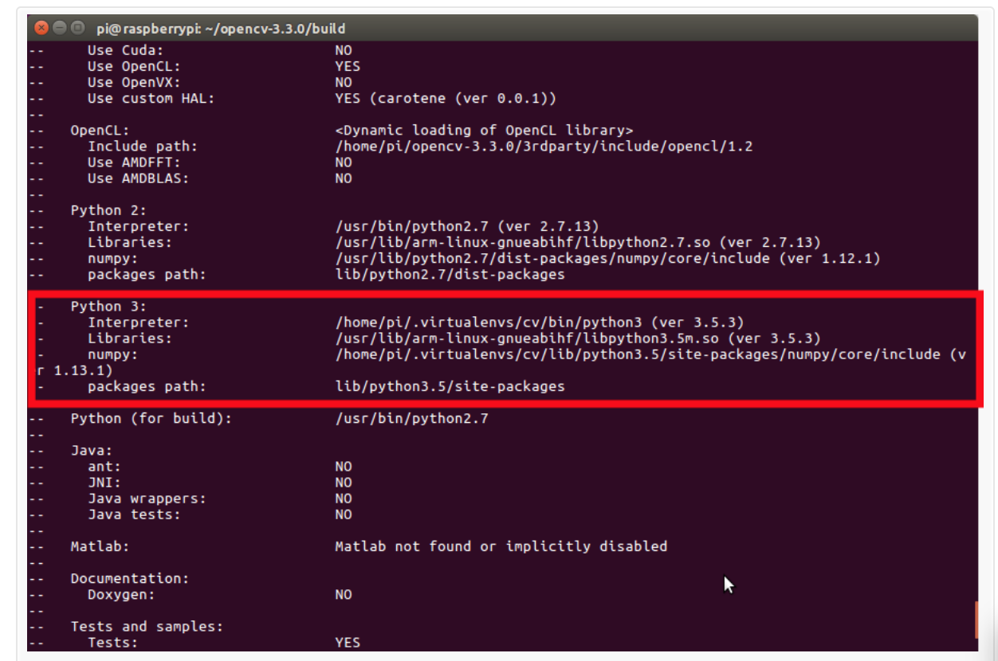

**Configure your swap space size:**

Open your /etc/dphys-swapfile and then edit the CONF_SWAPSIZE variable:

sudo nano /etc/dphys-swapfile

Change “CONF_SWAPSIZE=100” to -> “CONF_SWAPSIZE=1024”

And save file

sudo /etc/init.d/dphys-swapfile stop

sudo /etc/init.d/dphys-swapfile start

make -j4 ( 1hr 30 min it takes)

sudo make install

sudo ldconfig

(use python version in below command as per your version)

ls -l /usr/local/lib/python3.5/site-packages/

**Troubleshoot--**

**If site-packages not found**

**Then---**

**Cd /usr/local/lib/python3.5/site-packages**

**Run ->**

**ln -sf dist-packages/ site-packages/**

cd /usr/local/lib/python3.5/site-packages/

sudo mv cv2.cpython-35m-arm-linux-gnueabihf.so cv2.so

------

Test to check if install successful

source ~/.profile

workon cv

python

>>> import cvz2

>>> cv2.__version__

'3.3.0'

>>>

If this shows, we are all set :)

#### **Don’t forget to change your swap size back!**

Open your /etc/dphys-swapfile and then edit the CONF_SWAPSIZE variable:

CONF_SWAPSIZE=100

sudo /etc/init.d/dphys-swapfile stop

sudo /etc/init.d/dphys-swapfile start

------------------------------------------

Project code

source ~/.profile

workon cv

U should see (cv) pi@raspberry:~$

Edit /etc/modules files and add below line to end of it.

bcm2835-v4l2

And save.

pip install pillow

Clone the code

git clone https://github.com/ppundir/facerecognition

Files to be run are in FacialRecognition folder

Step1 : run face_dataset.py

<enter user id end press return>

Give 1 and press enter.

**Enable Camera**

sudo raspi-config

Interfacing->Camera ->Enable

Reboot: sudo reboot

Run 01_face_dataset.py everytime u want to capture new face in video… for training ..as of now 10 samples it takes

Step 2:

Run face_training.py

Step 3:

Edit face_detection.py

Here names = ['None', 'Pawan', 'Ritik', 'Shobhit', 'Mayank', 'Ashish', 'Amit']

Which means for id 1- name is pawan in array…

For id 2- name is Ritik etc…

Give corresponding names as per id in step 1.

Now u can run python_facedetection.py

Site---

http://setosa.io/ev/image-kernels/

Ignore this warning to reset password for default

#click on network icon on top right corner.

Click here to set wifi country

India

Ok

Select ur wifi.

Open raspberry command prompt..(black shell)

Ifconfig to get its ip.

Wlan0 -> inet has the value

Sample: 172.20.6.236

##